# Operating Systems

# Final Project

CPSY-300-C

**Docker**

**Challenges 3 & 4**

## Name:

Rommel Hipos

**Date Submitted:**

August 5, 2024

## Challenge 3 - Full-stack application

### Steps

* Setup the environmental variable (.env) make sure the configuration is aligned with your local DB connection.

* Now Create the DB and create table for books, then insert the required records based on the given “init.sql”

* Navigate to challenge3 folder and perform “npm install” to initialize the required modules.

* Add a "public" folder with some assets.
* Add a file with the name index.html. It should contain your **name** and **SAIT ID** in the contents.

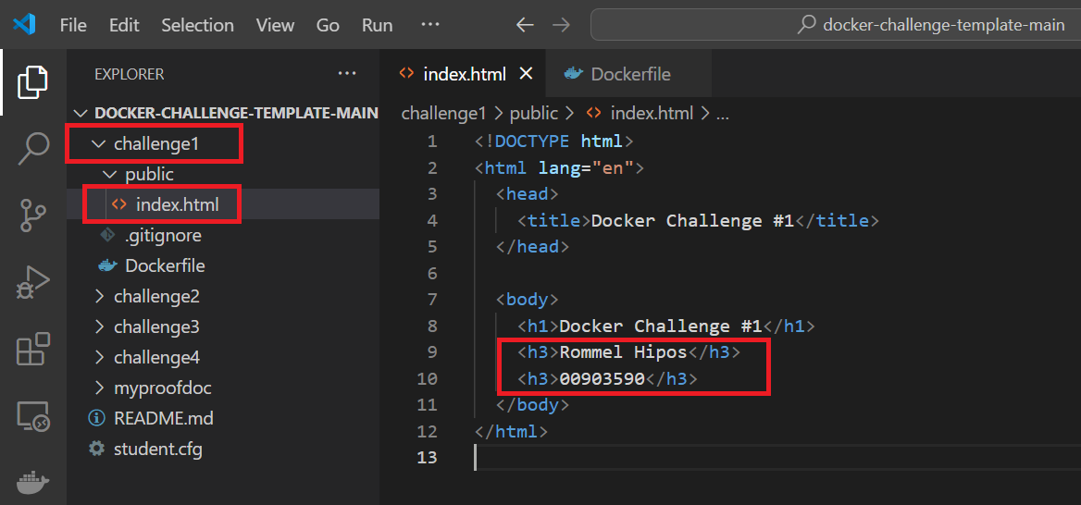

***Lessons Learned****: The purpose of these steps is to set up a basic Docker image that includes a simple web application structure. This structure includes static assets in a public folder and a minimal index.html file that can be served by a web server running inside the Docker container.*

* Create a Dockerfile to use NGinx to serve pages existent in the public folder.
* Create the Docker image.
* Execute docker with the right parameters.
* *Command to build the image*: ***docker build -t <name of the image> .***

* *Once the build is successfully executed, open the Docker desktop to view the image created.*

* Run the image to generate the container and set the port to 8080

* Now it’s ready to run inside the container.

***Lessons Learned****: With the help of these methods, I can quickly create a Docker image that encapsulates the whole web server setup into a portable and managed containerized environment, using NGinx to serve static web content from a public folder.*

* Commit the Dockerfile and public folder and push it to the remote repository.

### Expected outcomes

* When you request the URL “http://localhost:8080/” you will get a home page with your name and code.

***Lessons Learned****: Once the Docker image has been successfully created, you can run it using Docker Desktop to instantiate the container, making it ready to access.*

## Challenge 2 - NodeJS application

### Steps

* Use the folder challenge2.
* Extract the files present on challenge2.zip to the challenge’s root folder.
* Create a Dockerfile to build the server’s Docker container.

* Create the Docker compose file using NGinx and the API server from the previous step.
  + NGinx should listen on port 8080.

***Lessons Learned****: This ensures that NGinx is configured to handle requests on port 8080, acting as a gateway or reverse proxy to your API server.*

* *Command to build the image*: ***docker build -t <name of the image> .***

* *Once the build is successfully executed, open the Docker desktop to view the image created*

* Run the image to generate the container and set the port to 8080

* Now it’s ready to run inside the container.

***Lessons Learned****: The goal of all these steps is to set up and get ready a development or deployment environment inside the challenge2 directory. These consist of establishing the directory structure, incorporating required project resources from a compressed file, and setting up a Dockerfile to enable the deployment of containerized servers.*

* Open a browser and point it to the address <http://localhost:8080/api/books>.

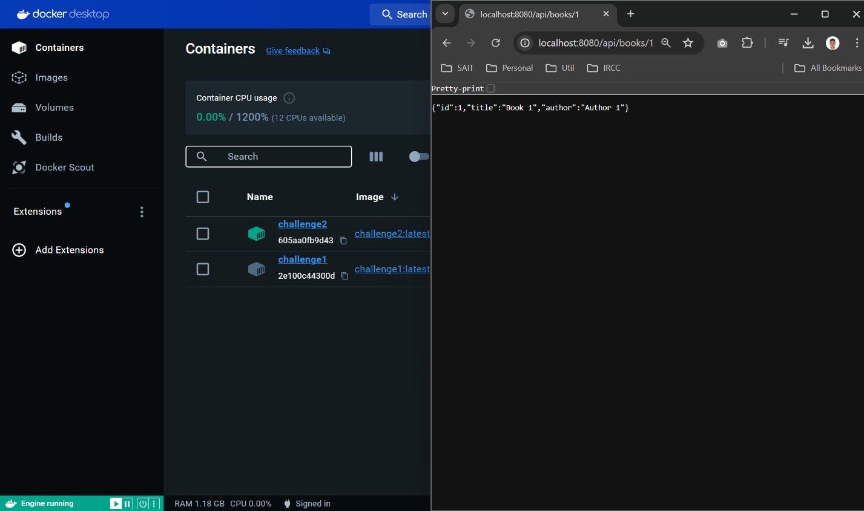

* Commit all files and push them to the remote repository.

### Expected outcomes

* When you access the following URLs:
  + “http://localhost:8080/api/books” you will get a JSON message with all books.

* + “http://localhost:8080/api/books/1” you will get a JSON message with just one book.

**Test Access Using my local VM:**

1. **Windows VM**
2. **Challenge 1**

1. **Challenge 2**

1. **Linux VM**
2. **Challenge 1**

1. **Challenge 2**

**Prerequisites:**

1. Install IDE to load the challenge template, in my case I use visual code as my editor.

<https://code.visualstudio.com/>

1. Install Docker Desktop based on your current operating system.

<https://www.docker.com/products/docker-desktop/>

1. This is optional, I used Postman to easily test the API (Challenge2). Postman is a powerful and user-friendly tool that allows developers to design, test, and document APIs.

<https://www.postman.com/downloads/>

# References

|  |  |
| --- | --- |
| [1] | [Online]. Available: https://docs.docker.com/. |
| [2] | [Online]. Available: https://www.docker.com/blog/getting-started-with-docker-desktop/#:~:text=Docker%20Desktop%20makes%20collaboration%20easy,Pausing%20and%20resuming%20a%20container. |
| [3] | [Online]. Available: https://github.com/IamStudentRommel/rommel-hipos-docker-challenge.git. |
| [4] | [Online]. Available: https://medium.com/@ajitfawade/how-to-create-a-docker-project-for-a-node-js-web-application-90-days-of-devops-e3623f46bf7. |
| [5] | [Online]. Available: https://medium.com/@ajitfawade/how-to-create-a-docker-project-for-a-node-js-web-application-90-days-of-devops-e3623f46bf7. |
| [6] | [Online]. Available: https://www.docker.com/blog/how-to-use-the-official-nginx-docker-image/. |